Bahria University,

Karachi Campus



LAB EXPERIMENT NO.

**10**

LIST OF TASKS

|  |  |
| --- | --- |
| TASK NO | OBJECTIVE |
| 1 | Name the fields in IP header. |
| 2 | What is the IP address of your computer? |
| 3 | Within the IP packet header, what is the value in the upper layer protocol field? |
| 4 | How many bytes are in the IP header? How many bytes are in the payload of the IP Computergram? |
| 5 | Explain how you determined the number of payload bytes. |
| 6 | Has this IP Computergram been fragmented? Explain how you determined whether the Computergram has been fragmented. |
| 7 | What is the value in the Identification field and the TTL field? |
| 8 | What information in the IP header indicates that the Computergram been fragmented? What information in the IP header indicates whether this is the first fragment versus a latter fragment? |

Submitted On:

20/10/2023

(Date: DD/MM/YY)

1. Name the fields in IP header.

* Differentiated Services Fields.
* Flags.
* Header Checksum.

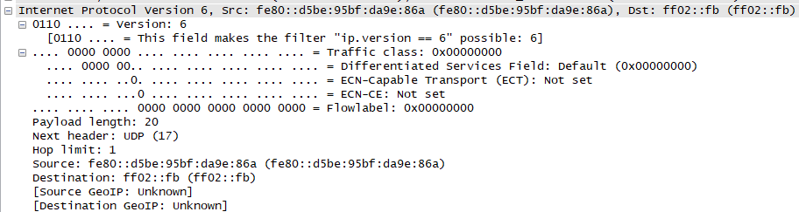

1. What is the IP address of your computer?

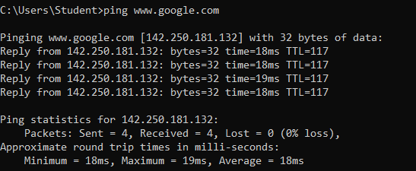

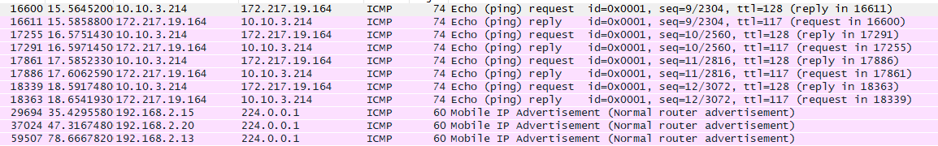



1. Within the IP packet header, what is the value in the upper layer protocol field?

**ICMP (1)**

1. How many bytes are in the IP header? How many bytes are in the payload of the IP Computergram?

**IP header: 20 Payload 40 (Total Length – Header Length)**

1. Explain how you determined the number of payload bytes.

**Total Length – Header Length**

1. Has this IP Computergram been fragmented? Explain how you determined whether the Computergram has been fragmented.

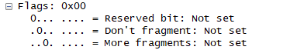

The more fragment bit = 0, so the data is not fragmented.

1. What is the value in the Identification field and the TTL field?

 

* **Time To Live :** 1
* **Identification:** 31292

1. What information in the IP header indicates that the Computergram been fragmented? What information in the IP header indicates whether this is the first fragment versus a latter fragment?

**The Flags bit for more fragments is set, indicating that the datagram has been fragmented. Since the fragment offset is 0, we know that this is the first fragment.**